Chapter 7, Solution 86.

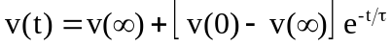
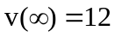, 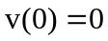
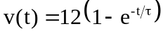
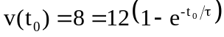
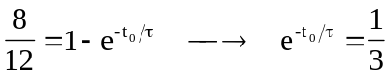
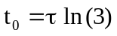

For 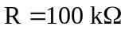,
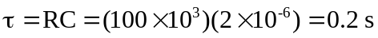
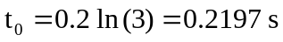

For 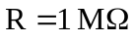,
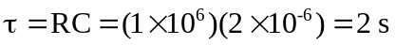
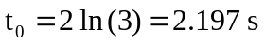

Thus,
